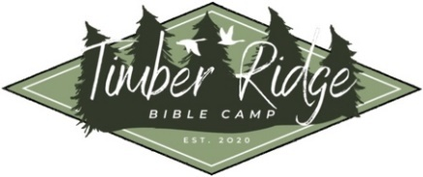
Timber Ridge Bible Camp
What to Expect

Welcome to Timber Ridge Bible Camp! We’re so excited to have you at camp! We hope you’re ready for great preaching, good food, and fun-filled activities. We do have a few things we would like you to know as you prepare to come to camp.
Part 1: Dress Code
As a part of a good Christian testimony, TRBC will have a dress standard for all campers and sponsors. All our staff will also dress to these standards.
Boys: Jeans, athletic pants, or shorts (knee length) and tee shirt
Girls: Tee shirt and knee length skirt or shorts (loose, to the knee) or loose-fitting jeans or loose athletic pants/ capris
Rules for everyone: No form fitting attire and no worldly graphic tee shirts (no cut off/
sleeveless shirts) & jeans may not have “fashion” rips or tears.
Part 2: Essential Items
- Bible
If staying overnight:
- Toiletries (bathroom supplies & towels)
- Clothing (as listed above)
- Bedding (sleeping bag, sheets, blankets, and pillows)
- Flashlights
Part 3: Prohibited items
- Weapons of any kind
- Alcohol and other abusive substances
- Fire starters or lighters
- Cell phones and electronic devices

